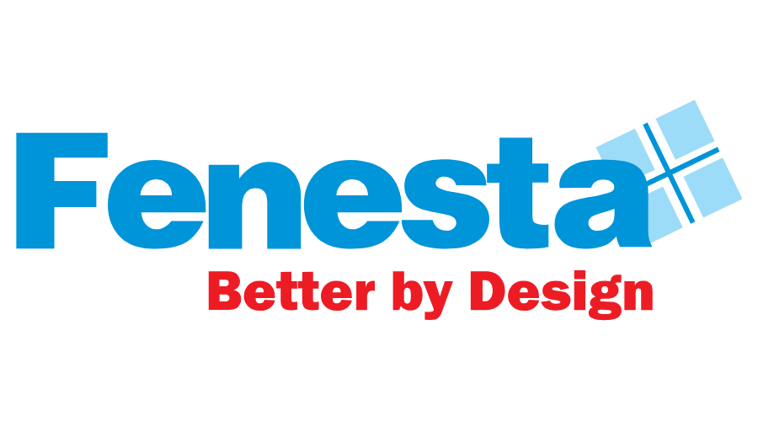
Fenesta expands its retail presence in Noida
Noida, 15 April, 2024: Fenesta, India’s largest Windows and Doors Brand which is also the market leader in its segment, reinforced its retail expansion with the opening of another showroom. The exclusive showroom, Furious Designs (OPC) Pvt. Ltd. is located at C-74, First Floor, Sector - 10, Noida-201301, and brings the best in class Aluminum windows and Doors, uPVC Windows & Door and Solid Panel Doors.
Speaking on the occasion, Mr. Saket Jain, Business Head, Fenesta said, “Our growth is driven by our dedication to provide a wide range of products and ensuring unparalleled customer satisfaction across the nation. Every new retail space is a proof of our excellent customer service and trust of our partners in us. Our showrooms are designed to be immersive experiential havens where customers can interact with our brand, learn about the offerings, and get a firsthand look to make informed decisions. We are excited to announce our newest opening, a strategic move to reach a wider audience across the country and sustain our market leadership.”

With this launch, Fenesta marks another milestone to ensure an interactive and informative buying experience for our existing and potential customers. Fenesta Showrooms have been successfully contributing to a significant customer reach and positioning as a market leader. With the rapid growth in Aluminum windows and Doors, uPVC Windows & Door and Solid Panel Doors categories in India, the brand endeavors to further increase its market share and maintain its leadership position in future.

He further added that “Due to the consistent support of our partners and customers, we have charted a great journey till now and look forward to many more landmarks ahead. I believe that our extensive product line, keen awareness of the market, and special focus on Tier 2 and Tier 3 markets helps us in our constant progress. Each aspect of our retail expansion has been carefully designed to captivate, educate, and leave our customers with lifelong memories.”

The Fenesta showroom located at C-74, First Floor, Sector - 10, Noida-201301 showcases a range of products from windows, doors and various design and color possibilities. With this launch, Fenesta now has a presence in more than 900 locations.

Fenesta is the only company in India to control the entire supply chain starting from the making of uPVC that goes into making the profile, to installation of end product, as well as after sales service. The range of products is specially designed in the UK and Austria to give consumers a well-engineered but contemporary style.
The products at Fenesta go through stringent tests and quality checks at every step to ensure performance in India’s varied and extreme climates. Fenesta products are immensely popular amongst leading builders, architects and interior designers across the country for its noise insulating, rain insulating, and dust proof features without compromise on aesthetics.
###
About Fenesta Building System:
Fenesta is India’s largest windows and doors brand and a part of the Rs. 12,080 Cr conglomerate DCM Shriram Ltd. Its installations across more than 4,00,000 homes have already crossed the magical 4 million mark. Empowered with the knowledge of India's extreme conditions, Fenesta has designed uPVC windows and doors that are able to withstand India's extreme climate also. After uPVC, Fenesta took another technological leap when it introduced its ultra-luxury Aluminium Windows and Doors and Solid Panel Doors. Headquartered in Gurgaon, Fenesta has more than 300 dealer showrooms and nine Signature Studios supporting its presence in more than 900 cities. With a dynamic direct sales force, Fenesta has successfully expanded its reach internationally, penetrating markets in the Maldives, Nepal, and Bhutan. Fenesta offers a complete customized end-to-end solution: survey, design, manufacture, delivery, installation and service to all its customers. The entire process is synchronized with the pace of each project. As a leader in the category, Fenesta takes pride in its ability to serve individual homes and large developers with equal ease.

For further information, please reach out to:
Gurudiksha Kaur | gurudiksha.kaur@adfactorspr.com

Rahil Siddiqui | rahil.siddiqui@adfactorspr.com

